**Testnet Wallet**

Look for the wallet in Google Play. Download it. It can only connect to Testnet.

Click on the QR code to get your address.

Use the address on your Testnet Wallet to get some coins from the faucet. Key in your address at one of the faucets.

Connect to a faucet to get some coins:

* <https://testnet-faucet.mempool.co/>
* <https://coinfaucet.eu/en/btc-testnet/>

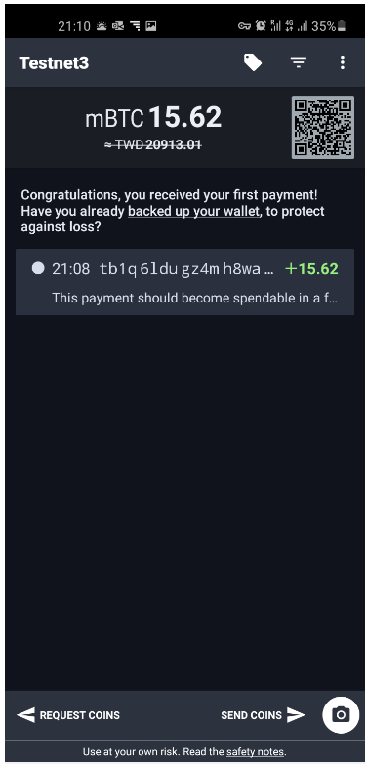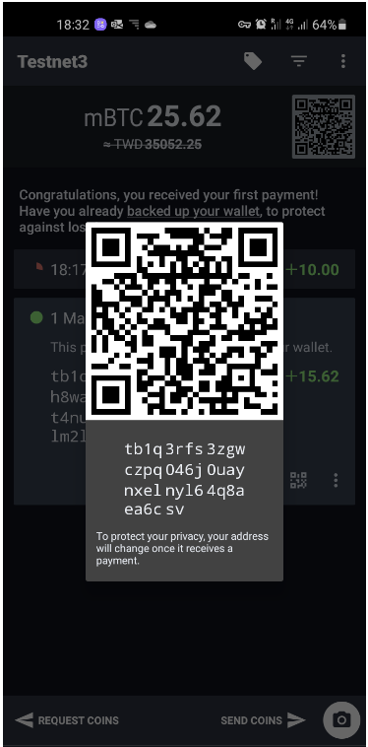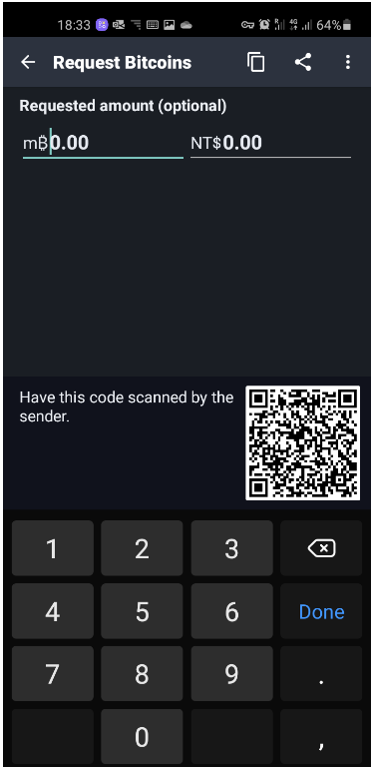

You can use the “request coins” function to get others to send coins to you. They will scan your QR code.

You can send coins to others by keying in their address. On the other hand, you can also scan their QR code using the camera function.

**Observe** what happens when you send btc to each other. How are the addresses changing?

**Electrum**

First download from : [https://electrum.org/#download](https://electrum.org/) . Download the portable version.

For actual use please verify the file signature before loading with actual bitcoins.

In this walkthrough we will use the testnet.

**Starting Electrum**

Locate the folder where Electrum executable is stored. Open a command window, then run by typing: (the version number may differ)

Electrum-4.0.9.exe --testnet

Note: use double dash

When asked: Use default_wallet/Standard wallet.

Also Create a new seed. You can choose either Segwit or Legacy.

Remember those seed words if want to re-use the wallet elsewhere (for example at home).

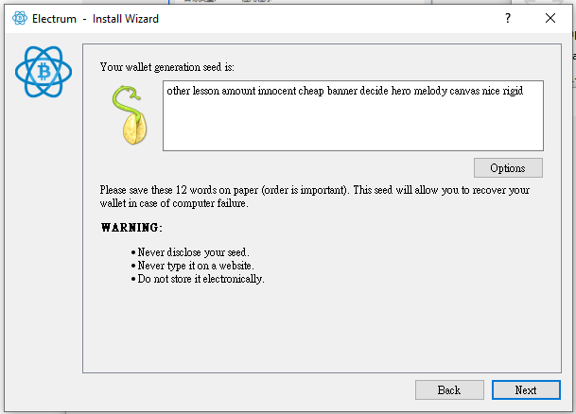

You will be asked to retype the seed words. Enter a password.

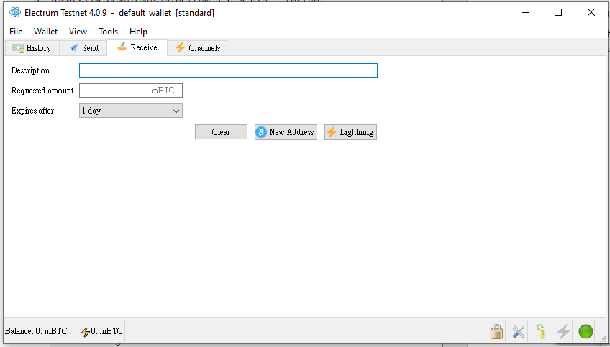

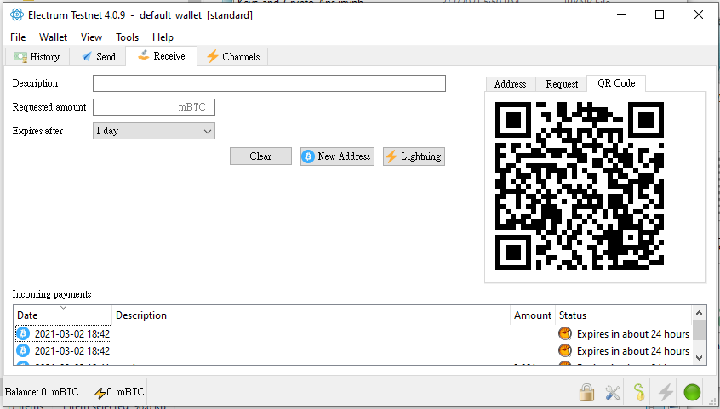

Now send coins from the TestWallet App to your Electrum Wallet. Click on the Receive Tab. Click on the New Address, and select QR Code.

Scan the QR code with your TestWallet App. Note the network fees required. In a moment the amount will appear on your Electrum Wallet. Initially it will appear as unconfirmed, as more miners confirm the transactions it will change to confirmed.

Now you know how to send and receive bitcoins.

**Block Explorer**

The transactions that you made can be seen at : <https://live.blockcypher.com/btc-testnet/>

All you have to do is to key in the addresses involved. Copy the address from Electrum and paste in to the block explorer website. You will something like this:

